Installation, Configuration, and Uninstall of the CitrixWorkspace App for Apple iOS Devices

**Contents**

Installation Steps for Apple iOS Devices………….................................................................................... 2

Configuring the Citrix Workspace App on your iOS Device ................................................................. 3

Secondary configuration of Citrix Workspace on your iOS Device………………………………………. 6

Uninstalling the Citrix Workspace App on your iOS Device ................................................................. 8

**Installation Steps for Apple iOS Devices**

**NOTE: Virtual Desktop users are not advised to install Citrix Workspace software on iPhone devices. The Virtual Desktop is designed for tablet and personal computer users.**

1. Open the **App Store** on the iOS device and search for ‘Citrix Workspace’.

2. In the same screen, tap the **Get** button.

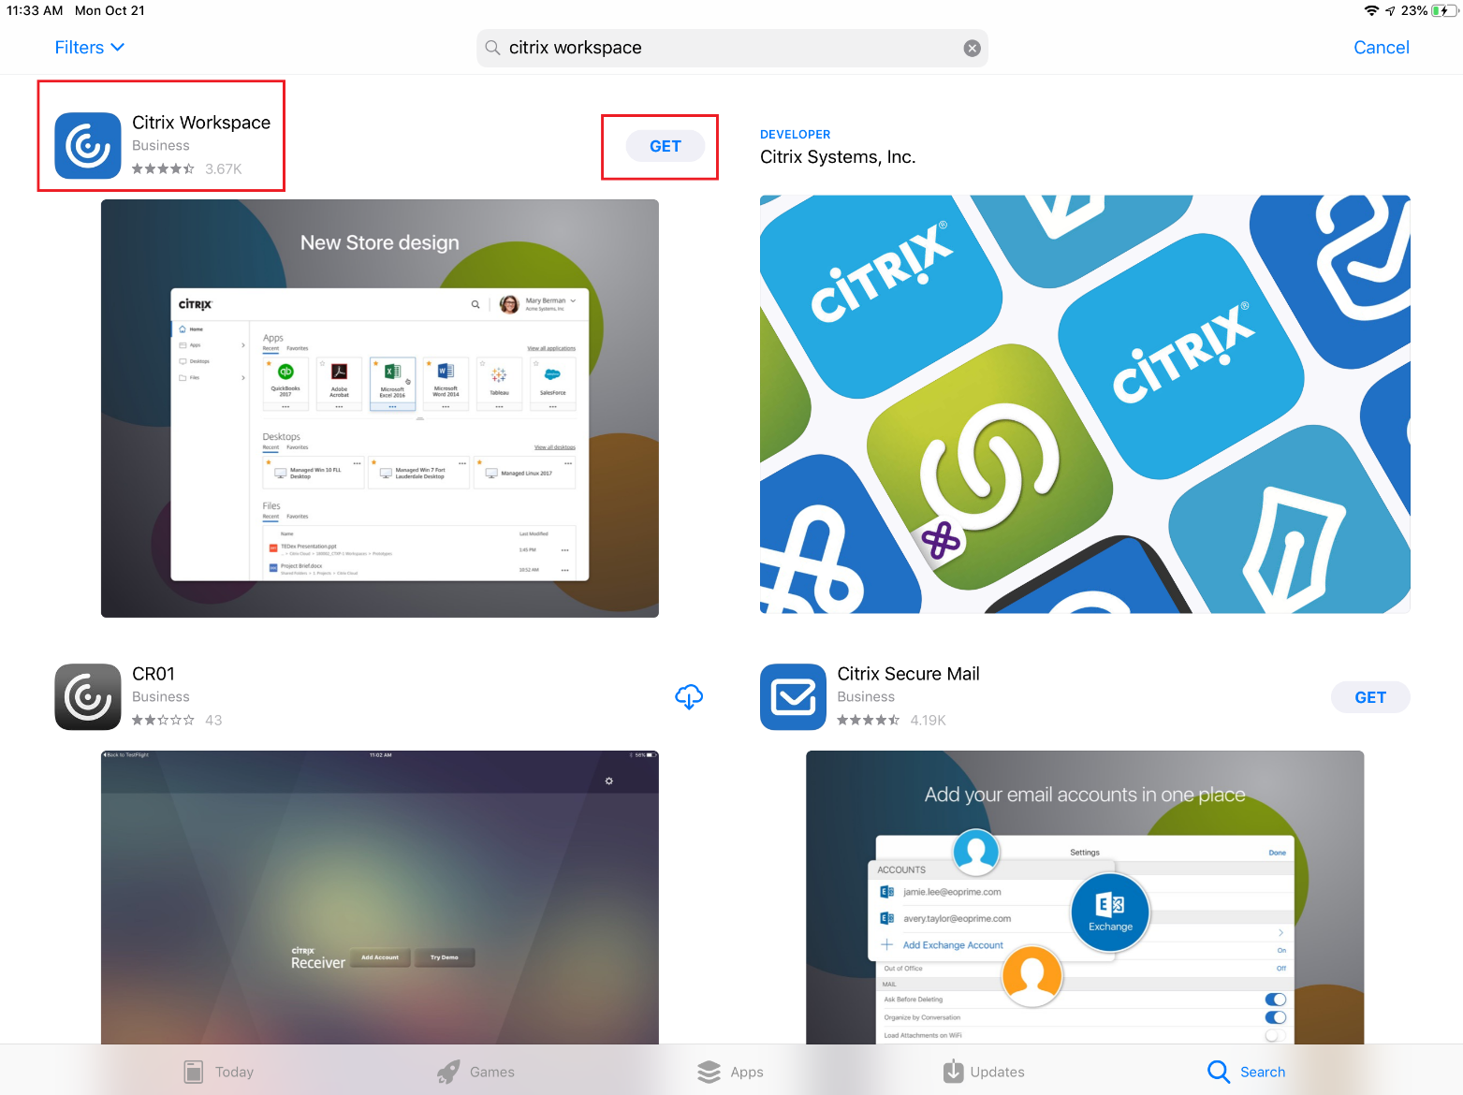

3. Click the **Install** button on the App Store dialog box to install the Citrix Workspace app. Next, enter your Apple ID password and click **Sign In** and the download/installation will begin.

4. Once the app is installed, press the **Home** button to minimize the App Store.

**Configuring the Citrix Workspace App on your iOS Device**

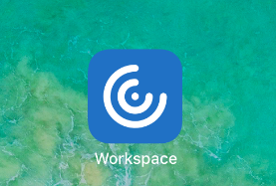1. Locate and Launch the **Workspace** Application from your ‘Home’ Screen

2. Once within the app, click the Get Started button and select the Options button (three dots) at the top right-hand corner in the following page. Select **Manual Setup**.

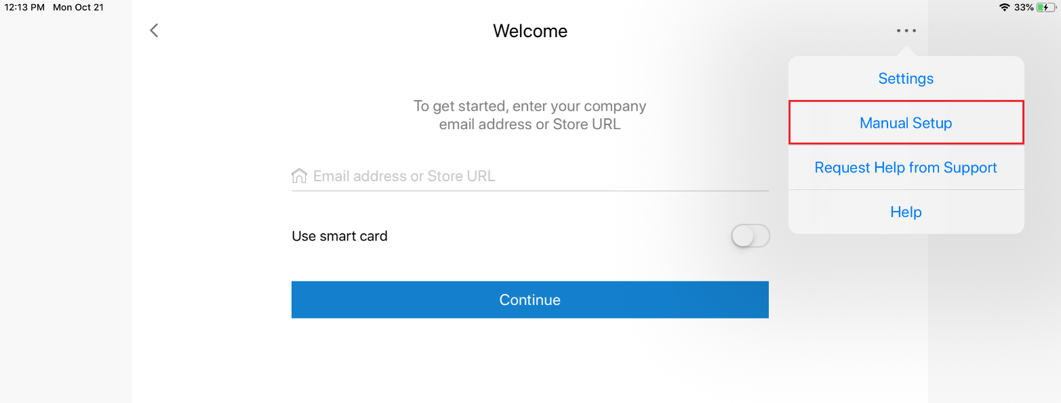

3. In the manual setup window ensure the following fields match the information below:

o **Address:** https://www.myapps-duke-energy.com

o **Access Gateway**

o **Enterprise Edition**

o Your **LAN ID**, **LAN Password**, and your **Domain** (NAM)

o **Security Token toggle switch** is on.

* The **Domain + Security token** option should be checked under the Security token toggle

switch. Enter your LAN ID, and LAN Password. Select **Save.**

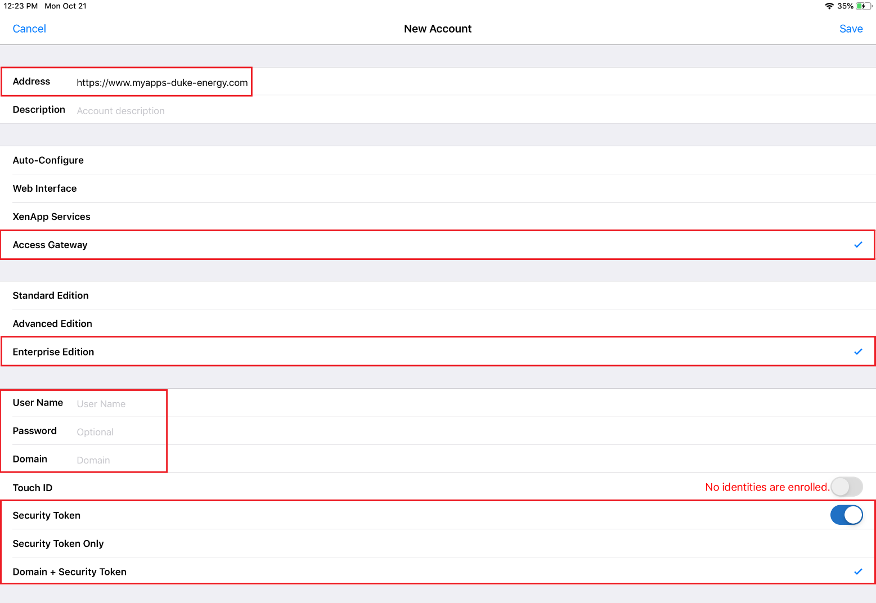

The next screen will prompt you to enter your RSA Token.

4. Enter your RSA token and select **OK**

5. The logon will proceed and you will notice a ‘*Loading*’ indicator while your application and/or desktop resources are enumerated. This may take a bit of time to complete.

6. After logging on, select the **+** sign on the left side of the Workspace App to display a list of all applications and/or desktop resources published to you.

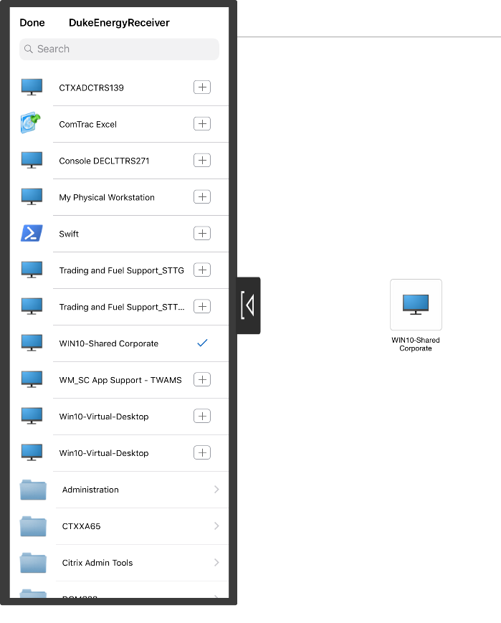

7. Select the **+** sign beside the application name, and the Workspace App will place an icon for the particular application directly on the app’s work space section.

8. Once you select the applications/resources, tap the **Arrow** on the middle / right side of the application list to dismiss the list.

9. Tap the icon for the application or desktop you wish to launch.

**Note:** *To bring back your list of available application/desktop resources, simply tap the*

*plus “****+****” sign icon on the left side of your screen.*

12. If you lose network connectivity or your device goes to sleep, your active session will change to a disconnected

state. To reconnect to your session, log in again. When you are finished working, close the application and/or desktop and tap the **Log Off** button on the Citrix Receiver menu.

**Note:** *To prevent losing data, save your data periodically, especially whenever you pause working with an application or within a desktop for a period of time.*

**Secondary configuration of Citrix Workspace on your iOS Device**

**NOTE**: If you have not set up an authentication method in O365, by using this job aid [How to Add or Change your O365 Profile Authentication method](https://dukeenergy.sharepoint.com/:b:/r/sites/O365Help/Shared%20Documents/Create%20or%20change%20your%20O365%20Authentication%20Profile.pdf?csf=1&e=Ppj4Kx), please do so **BEFORE** adding the Multifactor Authentication Citrix Portal URL

* + Be sure you set up a **primary** authentication method and a **secondary** authentication method.
    - Your office phone may automatically pre-fill; HOWEVER, be sure to **uncheck this option**. Your primary and secondary methods should be a combination of: a mobile phone number, secondary mobile phone number, a home phone number where you will be working or the [Authenticator application](https://dukeenergy.sharepoint.com/:b:/r/sites/portal/our-company/cybersecurity/Technical%20Resource%20Center/Authenticator%20App%20setup.pdf?csf=1&e=oqjrUH)
    - The **Authenticator application** is the **preferred primary** method of authentication.
  + Choose your **preferred primary authentication method** from the drop-down box under “what’s your preferred option?”

1. Locate and launch the **Workspace** Application from your ‘Home’ Screen
2. Once within the app, click the Get Started button and enter address: <https://www2.myapps-duke-energy.com> and click Continue. Next, enter your **LAN ID** and **LAN Password** and click **Sign in** afterwards.

**NOTE**: You will be prompted to authenticate via the method that you setup within your Office 365 Authentication Profile:

* Via a call to a phone number you provided during setup (e.g., mobile phone number, secondary mobile phone number, or home phone number where you will be working)
* The Microsoft Authenticator application 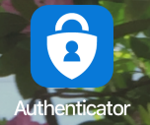

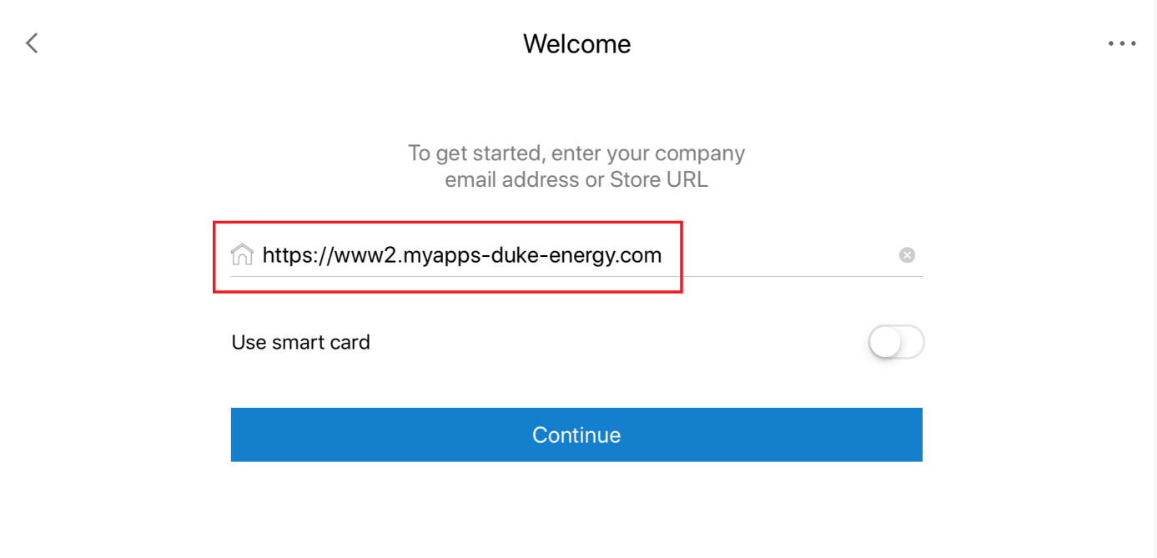

3. After logging on, select the **+** sign on the left side of the Workspace App to display a list of all applications and/or desktop resources published to you.

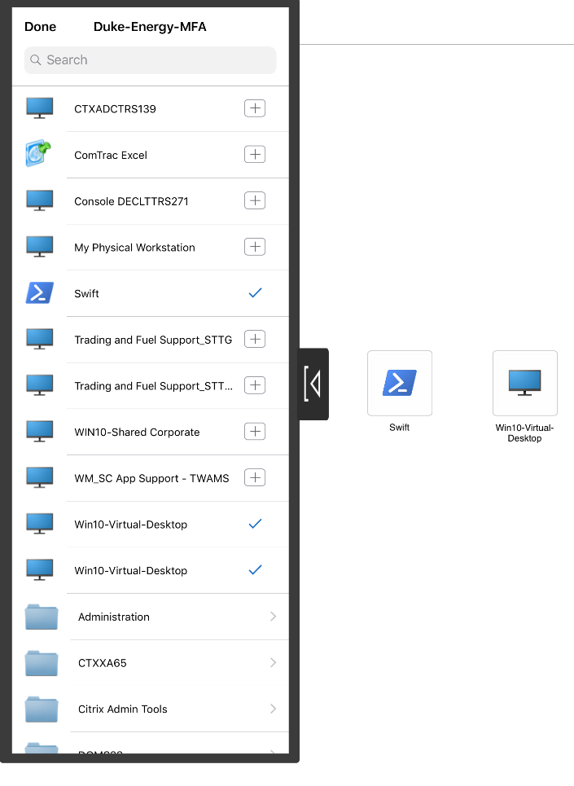

4. Select the **+** sign beside the application name, and the Workspace App will place an icon for the particular application directly on the app’s work space section.

5. Once you select the applications/resources, tap the **Arrow** on the middle / right side of the application list to dismiss the list.

6. Tap the icon for the application or desktop you wish to launch.

**Note:** *To bring back your list of available application/desktop resources, simply tap the*

*plus “****+****” sign icon on the left side of your screen.*

7. If you lose network connectivity or your device goes to sleep, your active session will change to a disconnected

state. To reconnect to your session, log in again. When you are finished working, close the application and/or desktop and tap the **Log Off** button on the Citrix Receiver menu.

**Note:** *To prevent losing data, save your data periodically, especially whenever you pause working with an application or within a desktop for a period of time.*

**.**

**Uninstalling the Citrix Receiver on your iOS Device**

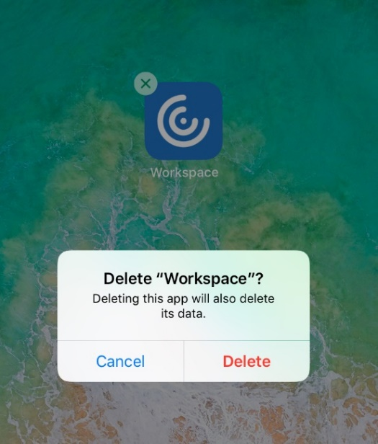

1. Place and hold your finger on the Citrix Workspace application icon until all icons on the iOS device begin to shake.

2. Tap the small ‘x’ at the top left of the Citrix Receiver application.

3. Tap the **Delete** button on the dialog to remove the application from your iOS device.